**AWS – Creating a Static Website on S3**

**Topics**

* Step 1: Create a bucket
* Step 2: Enable static website hosting
* Step 3: Edit Block Public Access settings
* Step 4: Add a bucket policy that makes your bucket content publicly available
* Step 5: Configure an index document
* Step 6: Configure an error document
* Step 7: Test your website endpoint
* Step 8: Clean up

**Step 1: Create a bucket**

**To create a bucket**

1. Sign in to the AWS Management Console (<https://console.aws.amazon.com>) as **Administrator** and open the Amazon S3 console under Services and **Storage**.
2. Choose **Create bucket**.
3. Enter the **Bucket name** *yourlastname****-s3-acc***.
4. Choose the N.Virginia Region to create the bucket.  
   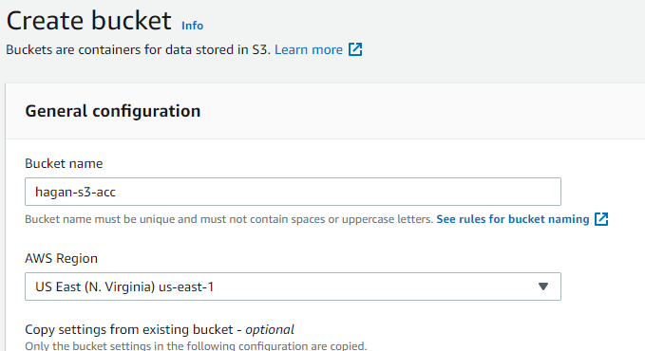
5. To accept the default settings and create the bucket, choose **Create bucket**.

**Step 2: Enable static website hosting**

After you create a bucket, you can enable static website hosting for your bucket.

**To enable static website hosting**

1. Sign in to the AWS Management Console and open the Amazon S3 console at <https://console.aws.amazon.com/s3/>. (you should already be logged in)
2. In the **Buckets** list, click the name of the bucket that you just created to enable static website hosting.  
   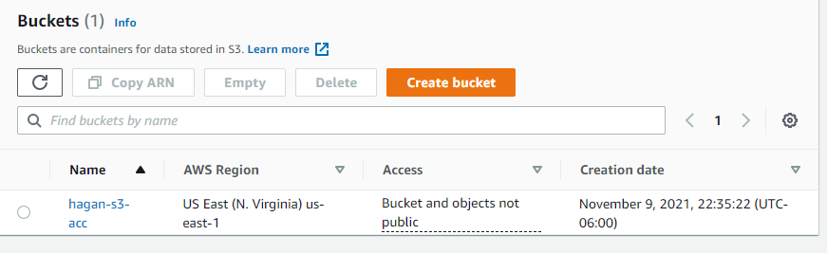
3. Choose **Properties**.  
   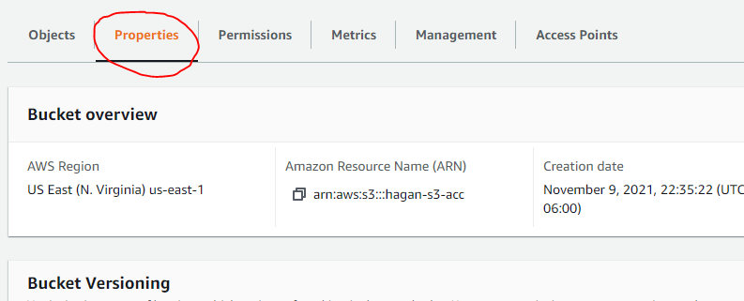
4. Scroll down and under **Static website hosting**, choose **Edit**.  
   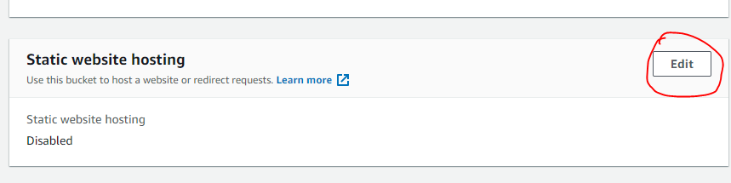
5. Under **Static website hosting**, choose **Enable** and **Host a static website**.  
   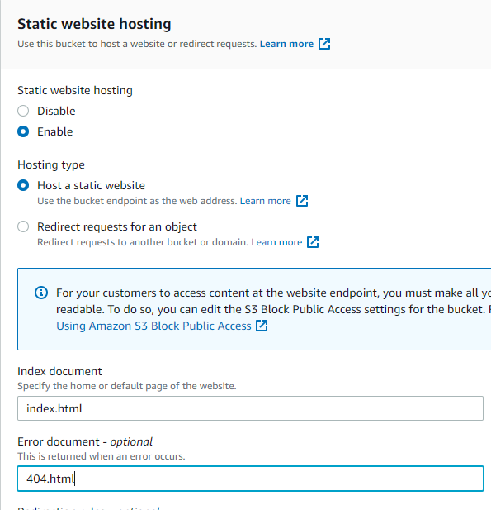
6. In **Index document**, enter the file name of ***index.html***.
7. To provide your own custom error document for 4XX class errors, in **Error document**, enter *404.html* as filename.
8. Choose **Save changes**.

Amazon S3 enables static website hosting for your bucket. At the bottom of the page, under **Static website hosting**, you see the website endpoint for your bucket.

1. Under **Static website hosting**, note the **Endpoint**.

The **Endpoint** is the Amazon S3 website endpoint for your bucket. After you finish configuring your bucket as a static website, you can use this endpoint to test your website. Use the copy icon and paste into a Notepad file.  
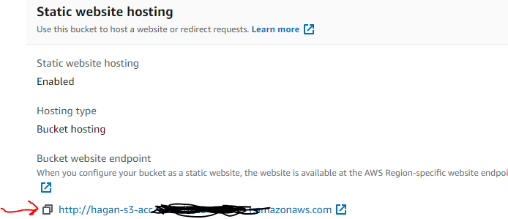

**Step 3: Edit Block Public Access settings**

By default, Amazon S3 blocks public access to your account and buckets. To edit, use these steps to edit your block public access settings.

1. Open the Amazon S3 console at <https://console.aws.amazon.com/s3/>. (If you are already on your new bucket’s page, scroll to the top then jump to Step 3)
2. Choose the name of the bucket that you have configured as a static website.
3. Choose the **Permissions** tab.
4. Under **Block public access (bucket settings)**, choose **Edit**.
5. Clear **Block *all* public access**, and choose **Save changes**. Type the word ***confirm*** to confirm saved changes and click the **Confirm** button.

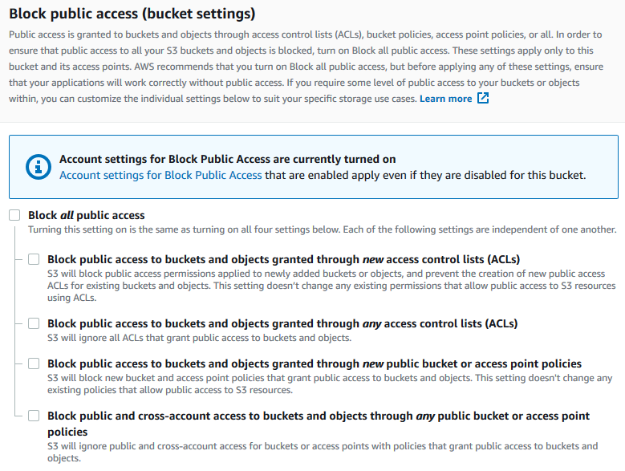

Amazon S3 turns off Block Public Access settings for your bucket. To create a public, static website, you might also have to [edit the Block Public Access settings](https://docs.aws.amazon.com/AmazonS3/latest/user-guide/block-public-access-account.html) for your account before adding a bucket policy. If account settings for Block Public Access are currently turned on, you see a note under Block public access (bucket settings).

**Step 4: Add a bucket policy that makes your bucket content publicly available**

After you edit S3 Block Public Access settings, you can add a bucket policy to grant public read access to your bucket. When you grant public read access, anyone on the internet can access your bucket.

1. Under **Buckets**, choose the name of your bucket and choose **Permissions** tab or if your already on the Permissions tab, scroll down to **Bucket policy**.
2. Under **Bucket Policy**, choose **Edit**.
3. To grant public read access for your website, copy the following bucket policy, and paste it in the **Bucket policy editor**.

{

"Version": "2012-10-17",

"Statement": [

{

"Sid": "PublicReadGetObject",

"Effect": "Allow",

"Principal": "*",

"Action": [

"s3:GetObject"

],

"Resource": [

"arn:aws:s3:::Bucket-Name/*"

]

}

]

}

4. Update the *Resource statement* to your bucket name.

In the JSON code bucket policy, *Bucket-Name* is a placeholder for *your* bucket name. To use this bucket policy with your own bucket, you must update this name to match your bucket name. To do this, copy your bucket name under Bucket ARN. Under Resource in the JSON script, replace Bucket-Name with your bucket name.  
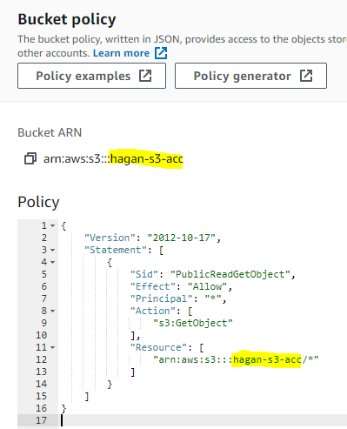

5. Choose **Save changes**.

A message appears indicating that the bucket policy has been successfully added.

If you see an error that says Policy has invalid resource, confirm that the bucket name in the bucket policy matches your bucket name. If you get an error message and cannot save the bucket policy, check your account and bucket Block Public Access settings to confirm that you allow public access to the bucket.  
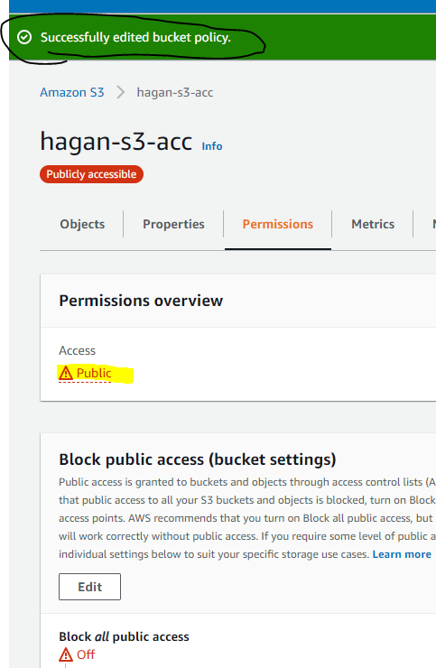

**Step 5: Configure an index document**

When you enable static website hosting for your bucket, you enter the name of the index document (for example, **index.html**). After you enable static website hosting for the bucket, you upload an HTML file with this index document name to your bucket.

**To configure the index document**

Create an index.html file in Notepad. Save it as ***index.html***. (Note the characters **&#39**; before letter **s** is to escape the single quote (‘) so it’s shows on your page.

<html xmlns="http://www.w3.org/1999/xhtml" >

<head>

<title>Yourlastname Website Home Page</title>

</head>

<body>

<h1>Welcome to YourFirstName**&#39;**s website</h1>

<p>Now hosted on Amazon S3!</p>

</body>

</html>

1. Save the index file locally.

The index document file name must exactly match the index document name that you enter in the **Static website hosting** dialog box. The index document name is case sensitive. For example, if you enter *index.html* for the **Index document** name in the **Static website hosting** dialog box, your index document file name must also be *index.html* and not Index.html.

**Step 6: Configure an error document**

**To configure an error document**

Create an error document called **404.html**.  
  
 <html xmlns="http://www.w3.org/1999/xhtml" >

<head>

<title> Yourlastname Error Page</title>

</head>

<body>

<h1>There is an Error!</h1>

<p>please check your link!</p>

</body>

</html>

1. Save the error document file locally.
2. To upload the index and error document to your bucket, click on **Objects**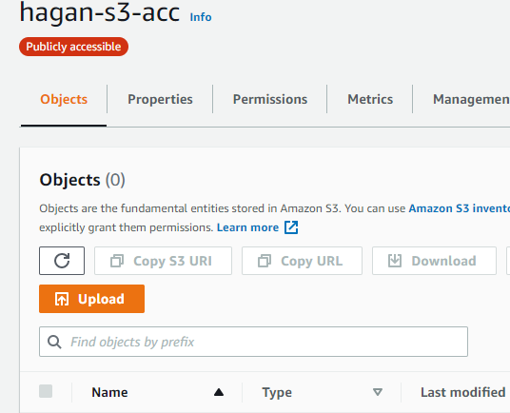
3. Click **Upload**
4. Click the **Add files** button. (or you can drag and drop files)
5. Locate your index.html and 404.html
6. Click the **Upload** button.  
   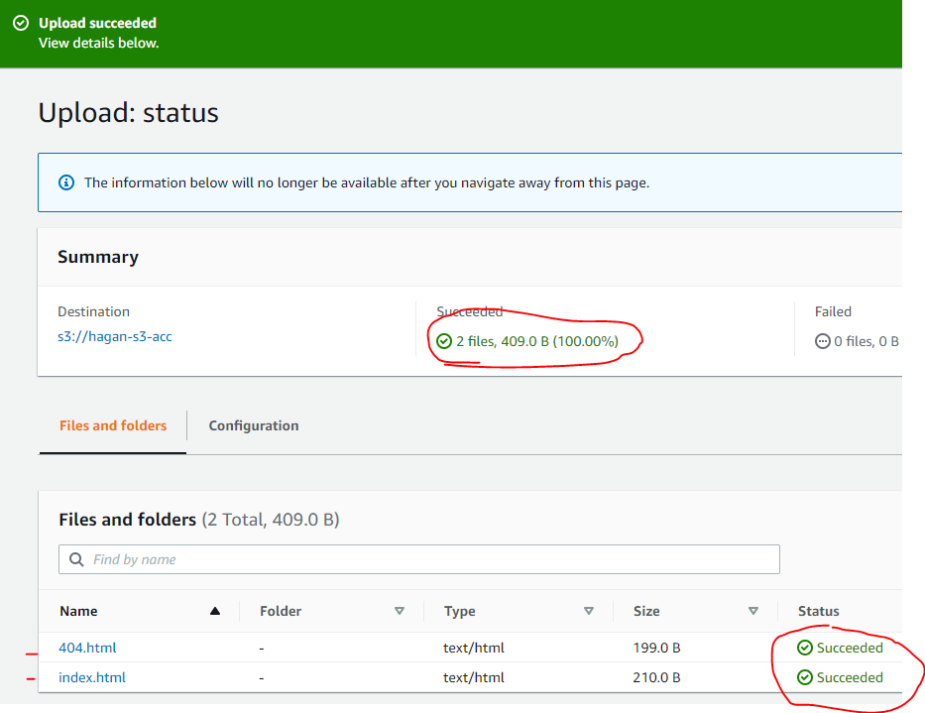
7. Click **Close** button  
     
   **Step 7: Test your website endpoint**

After you configure static website hosting for your bucket, you can test your website endpoint.

1. Under **Buckets**, click the name of your bucket. (If you copied the URL to Notepad earlier, skip to Step 4)
2. Choose **Properties**.
3. At the bottom of the page, under **Static website hosting**, click on the copy icon for your **Bucket website endpoint (Step 2 #9)**.
4. Open a Incognito or Private window in the browser and paste the URL**. Screenshot this and paste it in a Word Doc called yourlastname-S3-Lab.docx** **under a heading Screenshot1**.  
     
   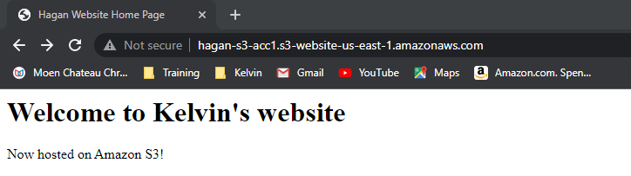
5. To test the error page, type **/test** at the end your URL in the window  
   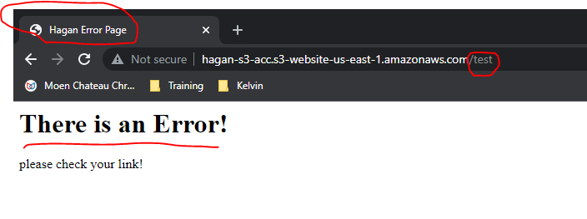
6. **Screenshot this and paste it in the same Word Doc called yourlastname-S3-Lab.docx under a heading Screenshot2.**
7. **Save the single Word doc and upload to Bb.**

**Step 8: Clean up**

You can delete this bucket.

1. On the **Buckets** page, select your Bucket and click the **Delete** button.  
   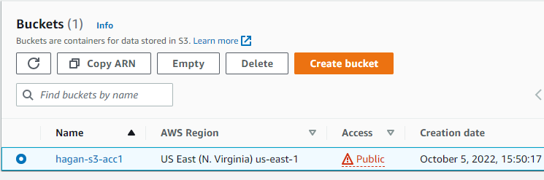
2. The Bucket must be empty to delete. On the following screen, click the ***empty bucket configuration*** link.  
   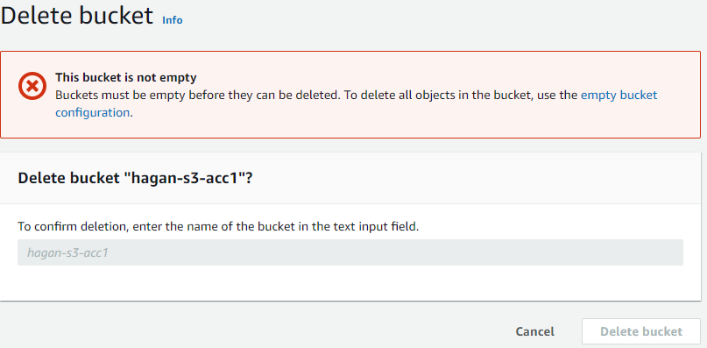
3. Type in the word **permanently delete** in the confirmation box and click the **Empty** button.  
   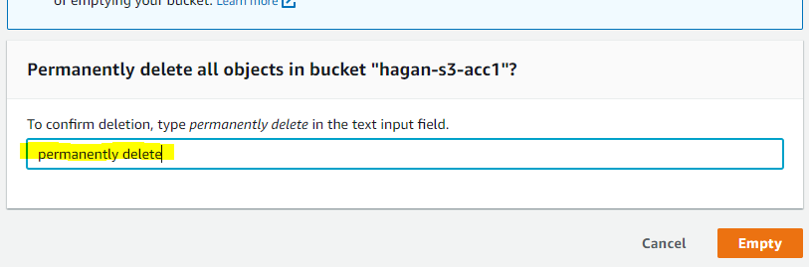
4. Make sure the bucket was emptied successfully and click Exit.  
     
   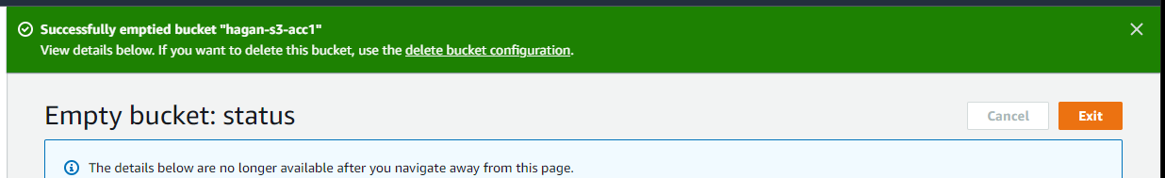
5. Now repeat Step 1. Type the bucket name on the next screen and click **Delete**.